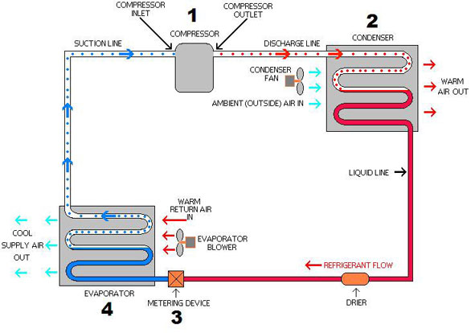

Use simply switches on the AC with a specific temparature without bothering how AC provides cooling - Abstraction

What happens internally?

Many people mistakenly think that their AC works by “creating” cold air. They don’t. Instead, they work by removing the heat inside your house and transferring it outdoors.
So how exactly does this process work?
How an air conditioner moves heat outside
Heat inside your home is absorbed and transferred outside via a cooling agent, or “refrigerant”. The refrigerant is contained inside coils that travel through a closed system. The coils guide the refrigerant from inside your home to the outdoors and back inside again.
Stations along the route manipulate the state, pressure and temperature of the refrigerant so that it absorbs or rejects heat at specific points. These stations include:
Evaporator
Compressor
Condenser
Let’s take a closer look at this process:
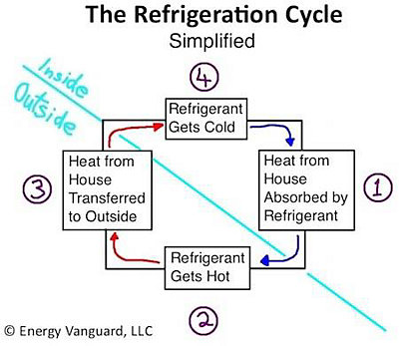

All these things are encapsulated inside AC unit with their internal functionalities , that’s why we get the above Abstraction.

